Project 4 Instruction and Command Arguments

Jiawei Wang 233474903

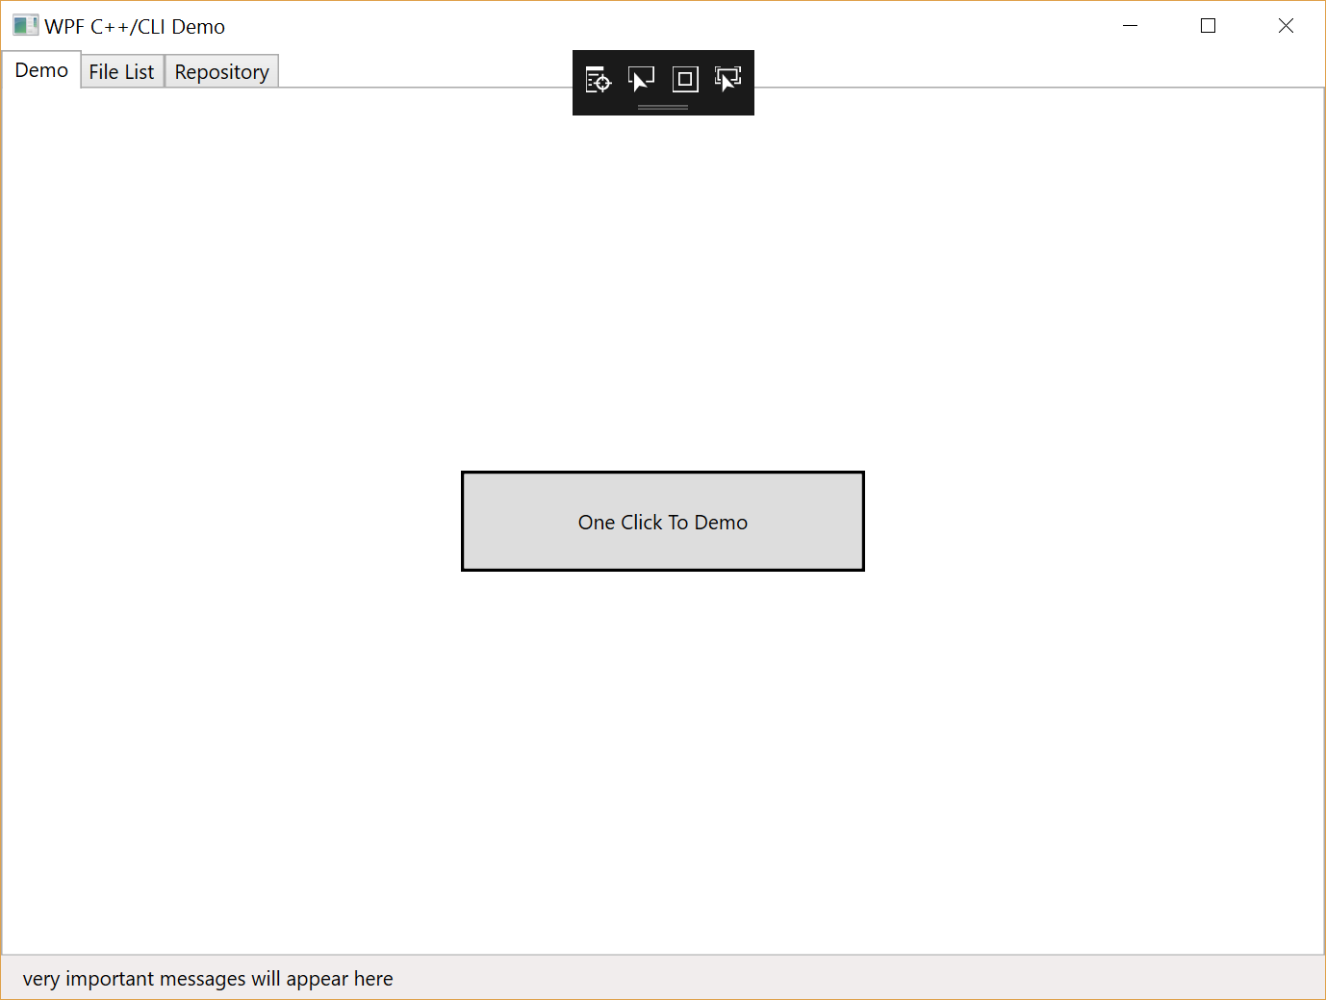

When we start the WPF-GUI-Client and Server. We can click “One Click To Demo” to see the demonstration of all the requirements. The Client will send all the files in “LocalRepository” to the Repository, and the Category is “Demo_Categroy”. And then it will start to analyze the dependencies in the whole repository and return the .html results to “Result”. then client will see the files in “Demo_Category” and the files that have no parent in that category. Finally, the client will lazy download one files. During the whole procedure, it will output when and how we implement these requirements.

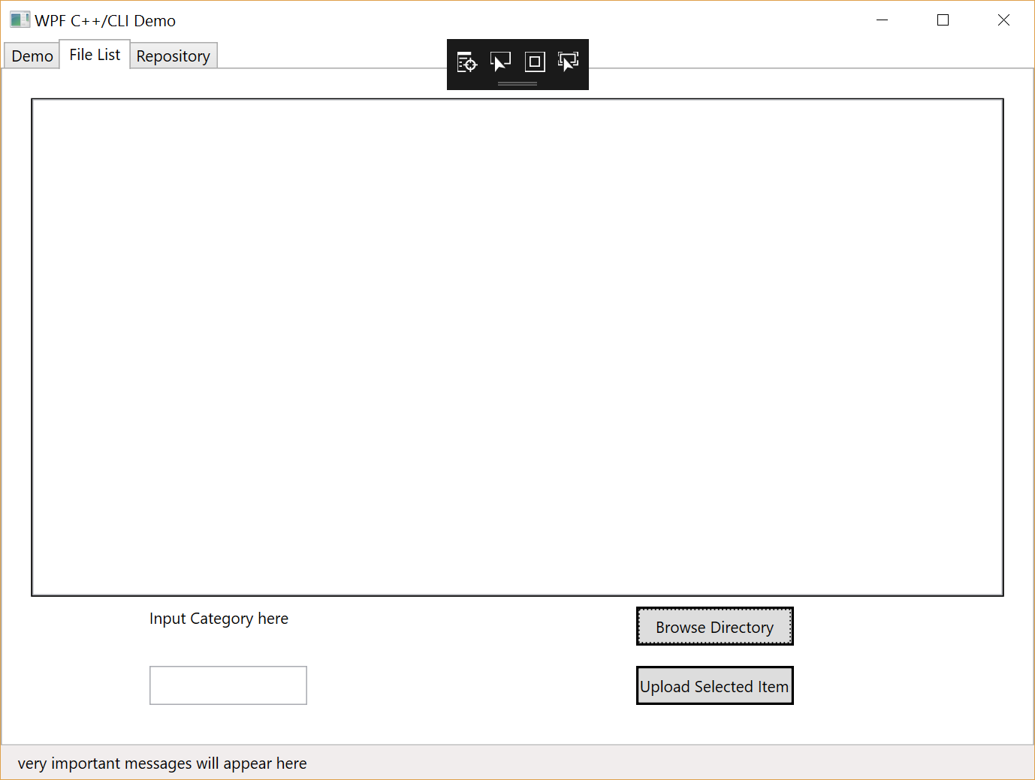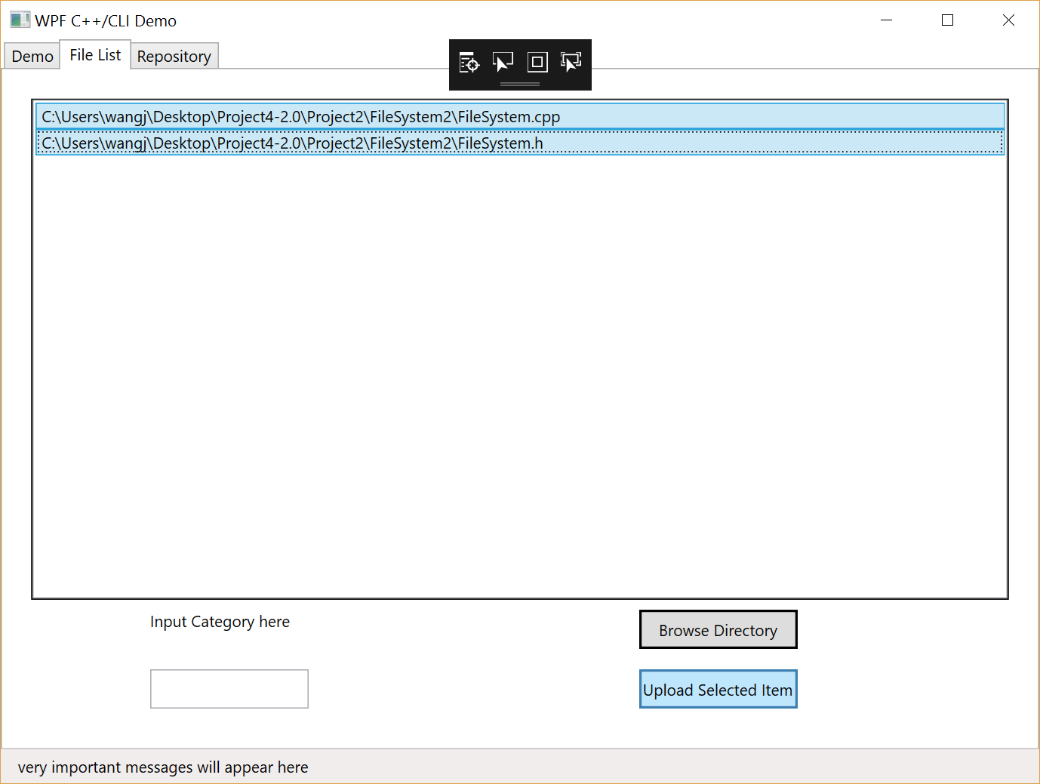

And then, we can also see the GUI. There is FileList Tab and Repository Lab.

In FileList Tab, we can browse a folder in your local computer and then all of the files in that folder will occur in the ListBox. Then we should select some files and must specify a category. Finally we click “Upload Selected Files”, all of selected items will be sent to the repository. If the server does not have that category, it will create a new folder for that.

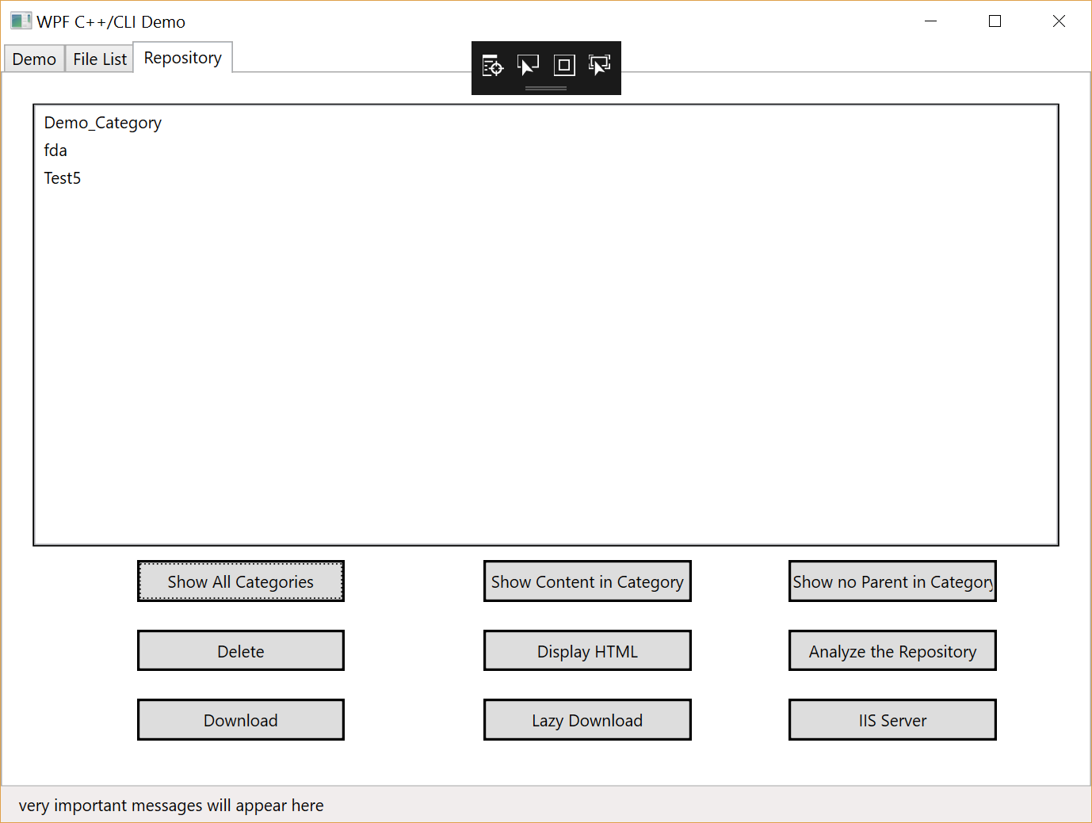

In Repository Tab, we can see 9 buttons.

We Click “Show All Categories”, it will show all the categories in Repository.

And then we can click “Show Content in Category”, “Show no Parent in Category” to see the code file or code file which has no dependencies.

And we can also click “Display HTML” to see all the html files in Result Repository.

And if we click “Delete”, we can delete HTML, Code file or the whole category.

“Analyze the Repository” is where my project connects to Project 3. It will analyze all the files in the Repository and output the html files with index.html in the Result Repository.

By clicking “Download” button, you can download code files or html files. If you download html files, server will also send javascript and css file to the Local Repository.

By clicking “Lazy Download” button, you can only download the html files. But server will send other dependencies to the Local Repository. (Bonus)

By clicking “IIS Server” button, you can see the html online. The Result Repository is the virtual address of IIS. And you can specify the port in WPF project command line.

Command Line:

start Debug/Server.exe 8080 Repository/ Result/

start Debug/CppCli-WPF-App.exe 8081 8091 LocalRepository/

For Server.exe, the first argument is the port of listener, the second argument is the Code Repository, and the third argument is the HTML repository.

For CppCli-WPF-App.exe, the first argument is the port of client’s listener, the second argument is the IIS port what the client will visit. (that is [http://localhost:{%port}](http://localhost:%7b%25port%7d)). The third argument is the path of local Repository.

Thank you for reading this document.